User Adoption at Relax Inc

Relax Inc. makes productivity and project management software that's popular with both individuals and teams. They would like to increase the number of users that regularly use their product, and the definition of an adopted user is one that logs into the product on three separate days in a 7-day period. The goal is to identify factors that predict future user adoption for Relax Inc.

A few different types of classifiers were trained and used for predicting the classification of users using a 20% validation set. The models were optimized using GridSearchCV with 10-fold cross validation. The table below summarizes the findings of the four classifiers and the optimal parameters used. The table is ranked with descending scores for Accuracy, F1 score, and MCC, with the Gradient Boosting Classifier identified as the best model to use.

|  |  |  |  |  |  |  |
| --- | --- | --- | --- | --- | --- | --- |
| Classifier | Parameters | F1 | MCC | Accuracy | ROC_AUC | Recall |
| Gradient Boosting Classifier | {'learning_rate': 0.2, 'max_depth': 3, 'n_estimators': 10} | 0.898596 | 0.8835 | 0.972917 | 0.930808 | 0.872727 |
| Logistic Regression | {'C': 1.7999999999999998} | 0.889922 | 0.87316 | 0.970417 | 0.928085 | 0.869697 |
| Random Forest Classifier | {'max_depth': 9, 'n_estimators': 9} | 0.866142 | 0.846642 | 0.964583 | 0.90942 | 0.833333 |
| XGBoost | {'gamma': 2, 'learning_rate': 0.1, 'max_depth': 7, 'n_estimators': 20} | 0 | -0.01153 | 0.861667 | 0.499517 | 0 |

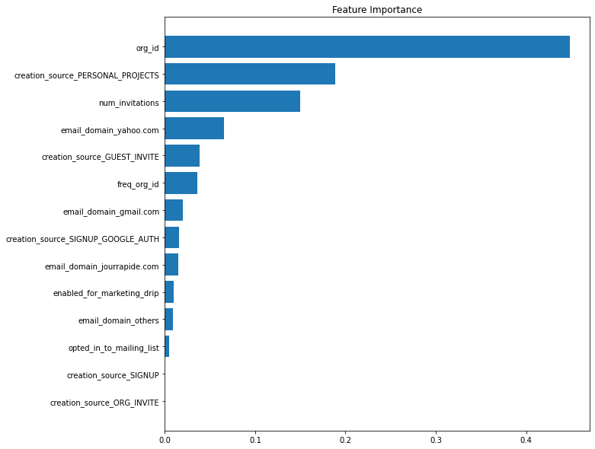The period, or the time between the account creation and the time of login, proved to be the feature of highest importance from all the different classifiers. This shows long term users are much more likely to be regular users of the product which seems logical. Other key features for predicting user adoption were:

* the organization ID,
* users who were invited to join other users’ personal workspace,

users who sent out the highest number of invitations, and

* yahoo email providers.

The least key features were identified as marketing drip and the mailing list.

The recommendations that are worth considering from here would be to offer organizations and individuals for referring/inviting users. It might be worth sending out surveys or to receive user feedback from to organisations that have the least number of invites- this may give an insight to why some organizations are using the product more than others and help target future directives for increasing user adoption.